HACKER RANK CHALLENGES:

1. <https://www.hackerrank.com/challenges/python-loops/problem?isFullScreen=true>

CODE:  
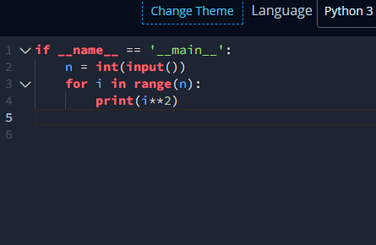

RESULT:



1. <https://www.hackerrank.com/challenges/python-arithmetic-operators/problem?isFullScreen=true>

CODE:

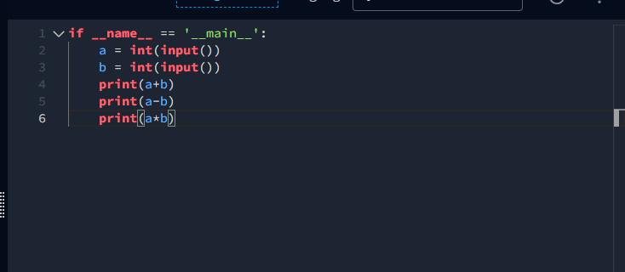

RESULT:

